**Name: ______________________ Class: _________________**

**M8-U2: HW #1 – Triangle & Angle Facts Date: __________________**

**1.** Luther makes a table in his shop class. A diagram of the top of the table is shown below:

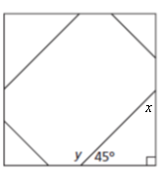

What is the measure of  and ? *Explain*.

**2.** If two angles are complementary and one angle measures 34°, what is the measure of the other angle?

**3.** If two angles are supplementary and one angle measures 120°, what is the measure of the other angle?

**4.** Find the value of *x* in  if the and .

**5.** Find the value of *x* in  if the and .

**6.** Given that Triangle AFE is isosceles and that and .

Find the value of all of the other angles.

Explain how you arrived at the measurement for .

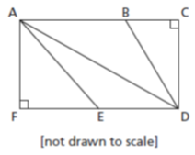

**7.** Find the value of the missing angle. Show your work or explain.

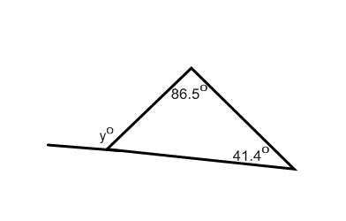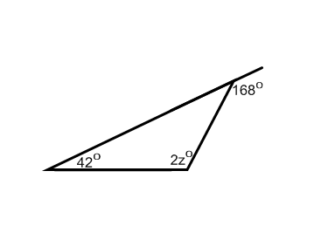**a) b)**

**Spiral:**

**8.** Simplify: 

**9.** Solve: 

**10.** Solve: 

**11.** The students from Mr. Jansen’s class and Mrs. Schmidt’s class went on a trip to a science museum. Admission was $8 per student. The total cost for all of the students’ admission was $320. Mr. Jansen has 16 students in his class. How many students does Mrs. Schmidt have?