**Name: ______________________ Class: _________________**

**M8-U2: Notes #1 – Triangle & Angle Facts Date: __________________**

**Triangle:**

The sum of the measures of the angles add up to __________________.

**Notation for Angles and Sides:**

  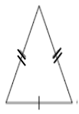

For #1-2: Draw and label a triangle with the given measurements, find the missing angle.

#1. m A = _____°

m B = 70°

m C = 40°

#2. m ABC = 100°

m BCA = 35°

m CAB = _____°

#3. Find the missing angle.



#4. Find the value of *x*. Find the degree measure of the angles.



#5. Fill in the missing angles in the diagram below:

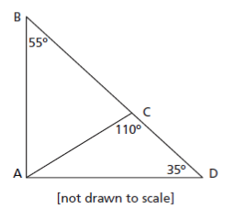

#6.

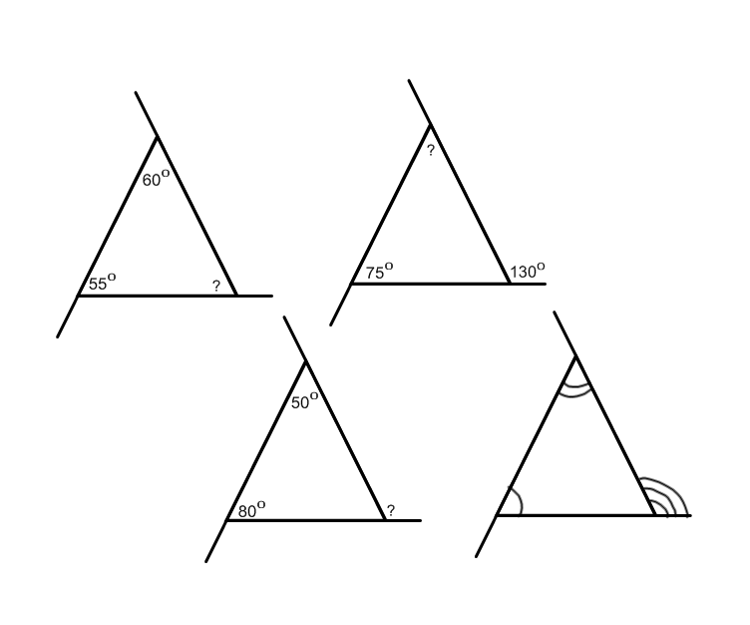

What generalizations can we make about the exterior angles of a triangle?

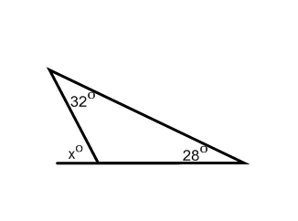**Try It!:** Find the value of the missing angle. Show your work or explain.

**a)**

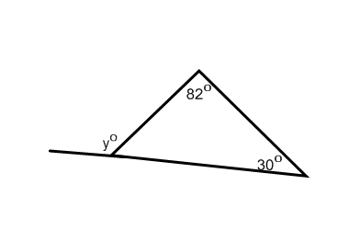

**b)**

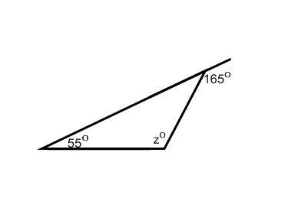

**c)**