**Name: ______________________ Class: _________________**

**M8-U2: HW #2 – Parallel Line Geometry Date: __________________**

**#1.** **a.** In the following diagram *m*║*l* cut by transversal *t*, find all eight angles if

*m*∠4 = 110°.



*m*∠1 = ________ *m*∠2 = ________ *m*∠3 = ________

*m*∠5 = ________ *m*∠6 = ________ *m*∠7 = ________

*m*∠8 = ________

**b.** Identify a pair of corresponding angles:

**c.** Identify a pair of alternate interior angles:

**d.** Identify a pair of alternate exterior angles:

**#2.** The *m*∠2 = 90°. Find the measure of the remaining angles if *m*∠4 = 30°.



*m*∠1 = ________ *m*∠2 = ________

*m*∠3 = ________ *m*∠5 = ________

Tell how you know their measure without the use of a protractor.

**#3.** Find the degree measure of.

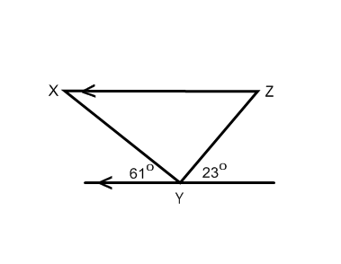

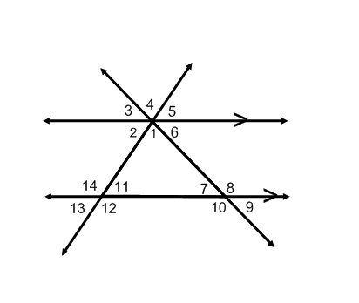**#4.** If the  and  find all the angles.

Explain how you determined .

**Spiral:**

**#5.** Solve and check the following equation: 

**#6.** Solve the following equation: 

**#7.** Five less than four times a number is nine more than twice the number.

What is the number?

**#8.** Deborah has two paintings in her portfolio and paints three more each week. Kai has twelve paintings in her portfolio and paints two more each week. After how many weeks will Deborah and Kai have the same number of paintings?