**Name: ______________________ Class: _________________**

**M8-U2: Notes #2 – Parallel Line Geometry Date: __________________**

**Warm-Up:**

The *m*∠2 = 90°. Find the measure of the remaining angles if *m*∠5 = 130°.



*m*∠1 = ________ *m*∠2 = ________

*m*∠3 = ________ *m*∠4 = ________

Tell how you know their measure without the use of a protractor.

**Example 1:**

In the following diagram *m*║*l* cut by transversal *t*, find the remaining angles if

*m*∠4 = 96° and *m*∠5 = 84°.



|  |  |  |
| --- | --- | --- |
| **Angle** | **Measure** | **Reason** |
|  |  |  |
|  |  |  |
|  |  |  |
|  |  |  |
|  |  |  |
|  |  |  |

What other relationships do you see?

|  |  |  |
| --- | --- | --- |
| **Angle Pairs** | **Reason** | **Other Angle Pairs that satisfies the given relationship** |
|  |  |  |
|  |  |  |
|  |  |  |

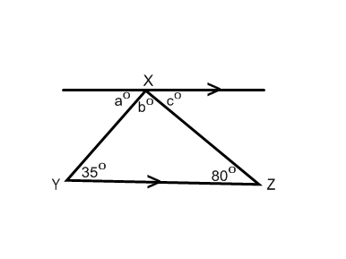**Example 2: Missing angles in parallel line geometry**

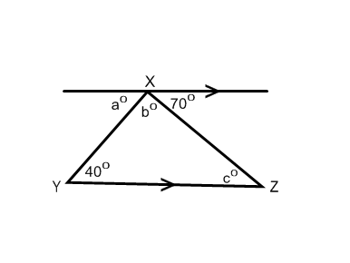

**Try It!:** Find the missing angle measures.

**a)**

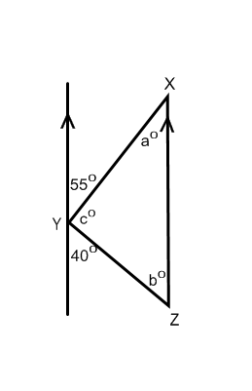

**b)**

**Example 3: Missing angles in parallel line geometry**

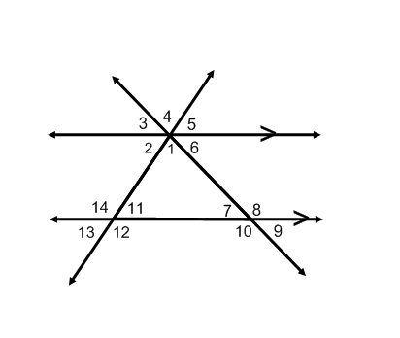

If the  and  find .

**Try It!:** Find the missing angle measures.

**a)** If the  and  find .

**b)** If the  and  find .

