**Name: ______________________ Class: _________________**

**M8-U2: HW #3 – Applications with Algebra Date: __________________**

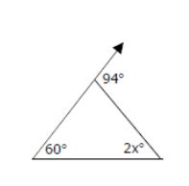**1.** Find the value of *x*. Show work and explain.

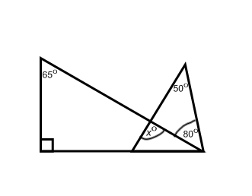

**2.** Find the value of *x*. Show work and explain.

**3.** In the following diagram *n1*║ *n2*.is cut by a transversal.

The  is 65o. Find the  and explain.

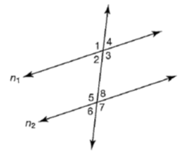

**4.** In the following diagram *x*║ *y*.is cut by a transversal.

The  is 102o. Find the  and explain.

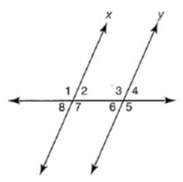

**5.** In the following diagram *a*║ *b*.is cut by a transversal.

The  is 118o. Find the  and explain.

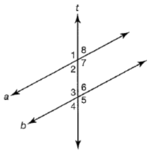

**6.** Find *y* and the missing angle measures. Show work and explain.

