**Name: ______________________ Class: _________________**

**M8-U2: Notes #3 – Applications with Algebra Date: __________________**

Objective: Use informal arguments to establish facts about:

-angle sum of a triangle

-exterior angle of a triangle

-angles created by parallel lines cut by a transversal

Student is provided with a pair of parallel lines.

**1.** Using a ruler, student will draw a minimum of two (2) transversals. Number each angle in the diagram.

**2.** Using a protractor, student will measure one angle created by **each** transversal. .

**3.** Student will write informal arguments to demonstrate their knowledge of the 3 facts stated in the objective.

**4.** All the other angles will be determined and explained.

**5.** Student *may* color each congruent angle the same color.

Mini-Project is worth 5 points

Scoring Rubric:

|  |  |  |  |  |  |
| --- | --- | --- | --- | --- | --- |
| **0 points** | **1** | **2** | **3** | **4** | **5 points** |
| -Not done  Or  -*Totally* Incorrect  Or  -Irrelevant  Or  -Incompetent at 8th grade level standards. | *¾ not done*  *Some done, but mostly not.*  *Mostly wrong* | *½ done*  *Many mistakes or one BIG mistake* | *¾ done*  *Some mistakes.* | *Just not 100% done.*  *Tiny mistake (calculation error).* | *100%*  -Complete  AND  -Correct  AND  -Clear communication.  AND  -Competent at 8th grade level standards. |

Measured Angles:  =  =

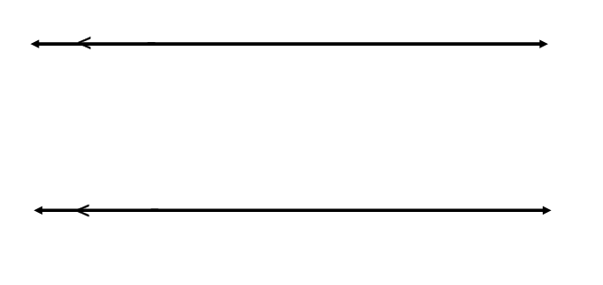

Informal Arguments:

**Example 1: Missing angles involving algebra**

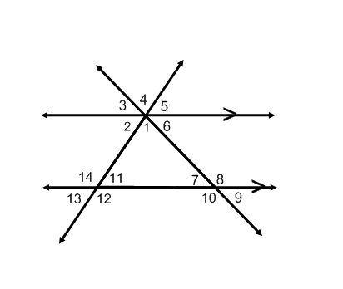**Example 2:** If the , and  find.

**Example 3:**

If the , and  find.

