**Name: ______________________ Class: _________________**

**M8-U2: Notes & HW #4 – Mixed Practice Date: __________________**

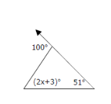**1.** Find the value of *x*. Show work and explain.

**2.** In Δ*ABC*, the *B* is twice the *A*, and the *C* is three times the *A*. Find the number of degrees in each angle of the triangle. Show work and explain.

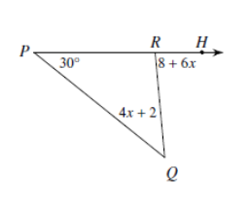**3.** Find the . Show work and explain.

**4.** In parallelogram ABCD, the  is 47o. What is the measure of consecutive ? Show work and explain.

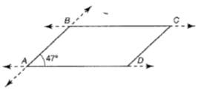

**5.** Two complementary angles measure  and .

What is the measure of the larger angle? Show work and explain.

**6.** Find the value of *y*. Find the degree measure of.



**7.**

Explain why.

**8. 9.**



**Spiral:**

**10.** 

**11.** Translate and solve.

The quotient of *h* and twelve, minus four results in negative 7.

**12.** Rosanna bought 14 CDs and 12 tapes for her party. She spent a total of $290.

Each CD cost her $13.

A) Write an equation to figure out the cost of the tapes.

Equation

1. Solve for the cost of the tapes.

Answer