**Name: ______________________ Class: _________________**

**M8-U2: Notes #5 – Similarity (proportionality) Date: __________________**

**Example 1:** **Congruent Figures**

**a.** Two triangles that are congruent have _______________________________.

______  ______

______  ______ 

______  ______

Therefore: 

**Example 2: Similar Figures**

**a.** Two triangles that are similar have ____________________________.

**AND**

**b.** Corresponding sides are ____________________________________.

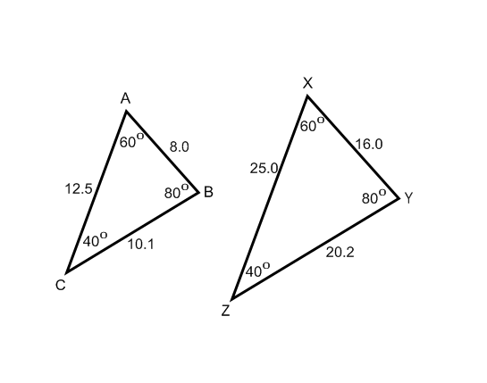



______

______ 

______

 

**Example 3: Finding missing lengths**

Given that rectangle *EFGH* is similar to rectangle *WXYZ*, find *t*.



**Try It!:**

**a)** In the figure, . Find *LM*.



**Example 4:** **Overlapping Similar Triangles**

The following figures are similar polygons. Find the unknown lengths.



**Try It!:**

The following figures are similar polygons. Find the unknown lengths.



**Example 5:** **Determining Similarity using Proportions**

Tell whether the pair of polygons is similar. Explain why or why not.

