**Name: ______________________ Class: _________________**

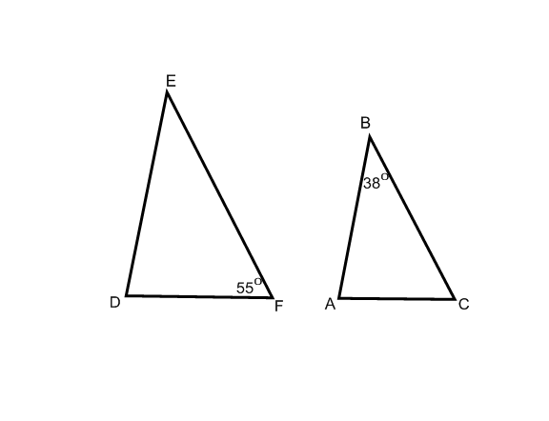**M8-U2: HW #6 – Similarity (angles) Date: __________________**

**1.** , Determine all of the angles in each triangle.

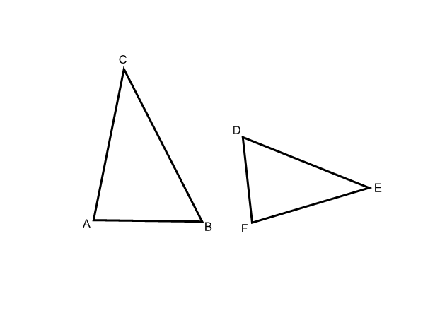**2.** The , , , .

Are the following triangles similar? Explain.

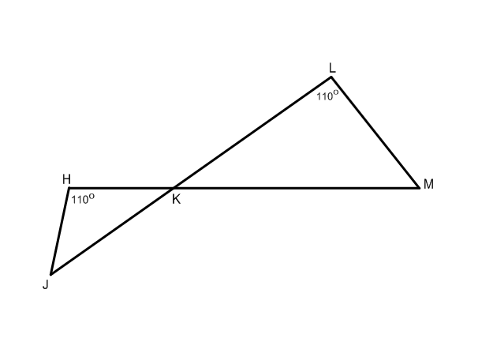**3.** Are the following triangles similar? Explain.

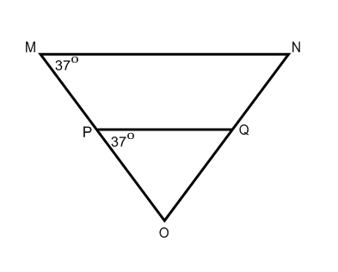**4.** Are the following triangles similar? Explain.

**5.** Are any triangles in the diagram below similar? Explain.

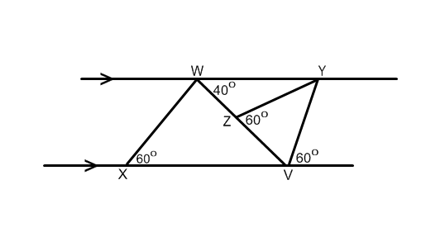

**Spiral:**

**6.** Angie is using similar triangles to find the height of a tree. A stick that is 5 ft tall casts a shadow that is 4 ft long. The tree casts a shadow that is 22 ft long. How tall is the tree?

**7.** Find the value of *x*. What is the ?



**8.** In isosceles Δ*ABC*, the measure of the vertex angle *C* is 30 degrees more than the measure of each base angle. Find the number of degrees in each angle of the triangle.