**Name: ______________________ Class: _________________**

**M8-U2: Notes #6 – Similarity (angles) Date: __________________**

**Warm-Up: Similar Figures**

**a.** Two triangles that are similar have ____________________________.

**AND**

**b.** Corresponding sides are ____________________________________.

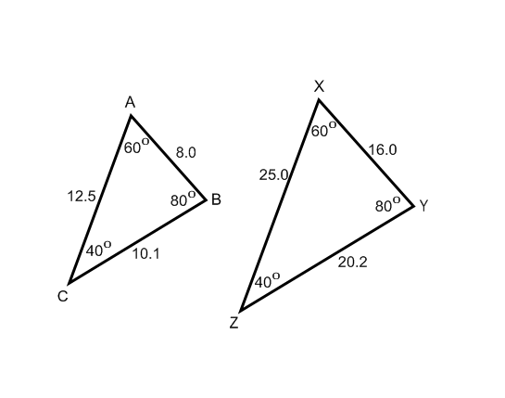



______

______ 

______

 

**Example 1: Stating that 2 Triangles are Similar**

, Determine all of the angles in each triangle.

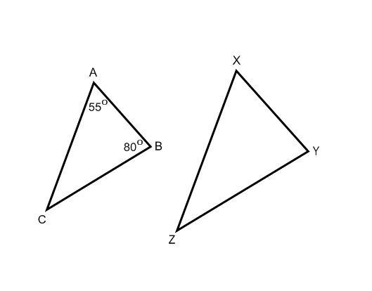

**Try It!:**

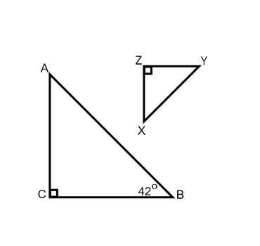**a.** , Determine all of the angles in each triangle.

**b.** 

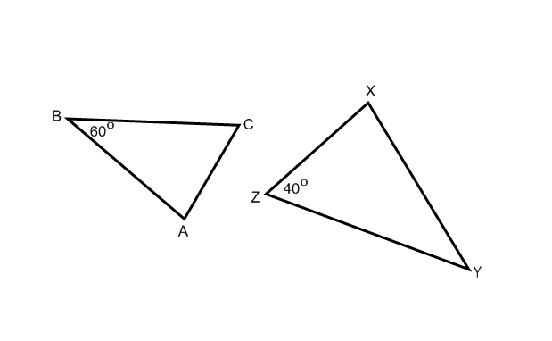

______

______

______

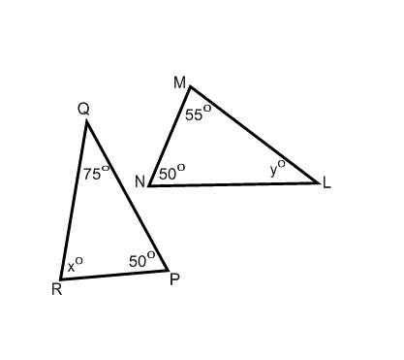

**Example 2: Determining Similarity**

Are the following triangles similar? Explain.

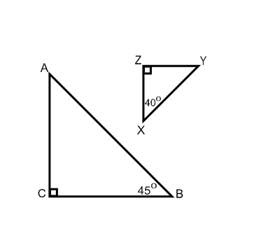**Try It!:**

**a.** Are the following triangles similar? Explain.

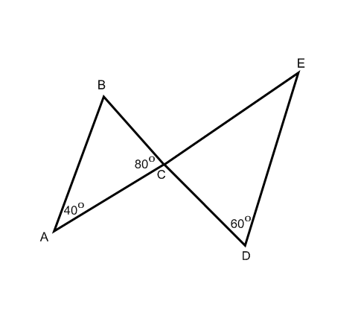

**b.** Are the following triangles similar? Explain.

**Example 3:**

In the diagram  and .

Are similar? Explain.

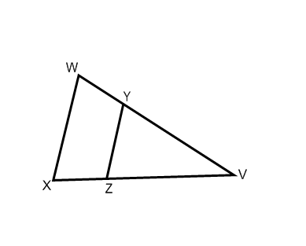

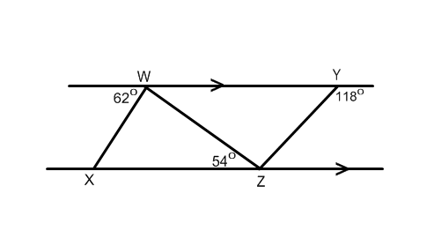

**Example 4:**

Are similar? Explain.