**Name: _____________________ Class: _________________**

**M8-U2: Lesson #7 – Unit 2 Geometry Task**

**Directions:**

For all 5 tasks:

**1.** Working with your group determine as many angle measurements as you can.

**2.** Working with your group determine as many congruent angle pairs as possible.

**3.** Determine whether the triangles are similar, not similar, or ‘it cannot be determined’. Explain your reasoning.

*Your group will be responsible to present your solution to one of the tasks to the class.*

**1. Are triangles *PQR* and *SRT* similar?**

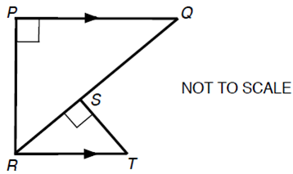

**2.**



**3.**



**4.**



**5. Are triangles *PRS* and *QSR* similar?**

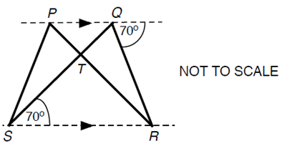

**Homework #7:**

**1.** A triangle has a perimeter 13.

The two shorter sides have integer lengths equal to *x* and *x + 1*.

What could be the lengths of the three sides of the triangle?

**2.** Three identical white shapes and three identical grey shapes are fitted together to make this pattern. How big is the angle marked n°?



*(Drawing not to scale)*

**3.** On this diagram label another angle whose measure is 80°.



**4.** The diagram below shows two triangles, triangle ABC and triangle ACD:



Are the two triangles similar? Explain, step by step, how you know.

**5.** The diagram below shows triangle BCD within triangle ACE.



Are the two triangles similar? Explain, step by step, how you know.