**Name: __________________________ Class: __________________**

**M8-U2: Lesson #8 - Geometry Review Sheet Total: 30 pts**

**Multiple Choice**

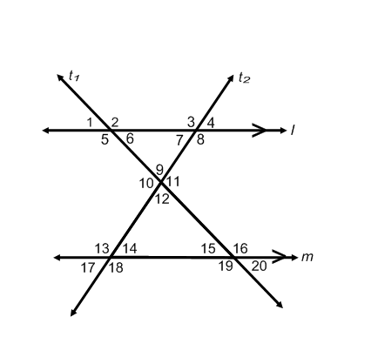*Identify the choice that best completes the statement or answers the question.* ***(2pts each)***

**Use the following figure to answer questions 1 – 5. *Note:*** *m*║*l* cut by transversal *t1* and *t2*

____ **1.** Which pair of angles are alternate interior angles?

**a)**  **b)**  **c)**  **d)** 

____ **2.** Which pair of angles are alternate exterior angles?

**a)**  **b)**  **c)**  **d)** 

____ **3.** Which pair of angles are corresponding angles?

**a)**  **b)**  **c)**  **d)** 

____ **4.** Which pair of angles are supplementary angles?

**a)**  **b)**  **c)**  **d)** 

____ **5.** Which pair of angles are vertical angles?

**a)**  **b)**  **c)**  **d)** 

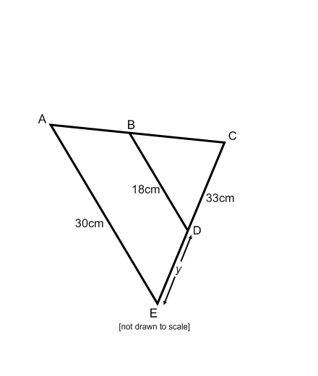**6.** . Find the value of *y*. Show work. ***(3 pts)***

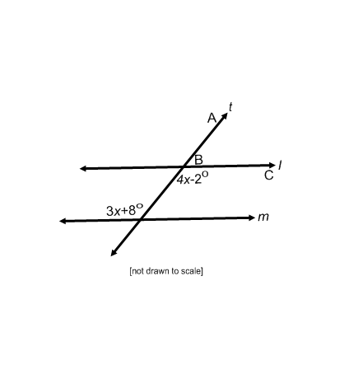**7.** In the following diagram *m*║*l* cut by transversal *t*. ***(3 pts)***

What is the measure of ? Show work ***and*** explain.

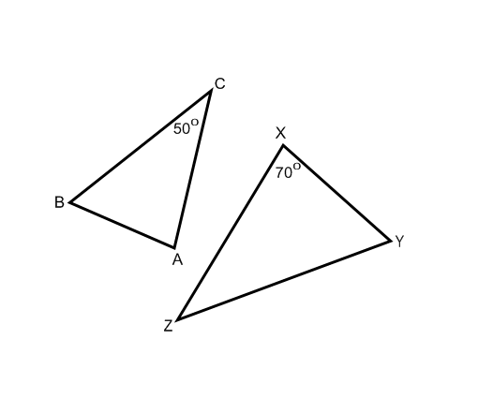**8.** . Label the missing angle measures in the diagram. ***(3 pts)***

The ___________________.

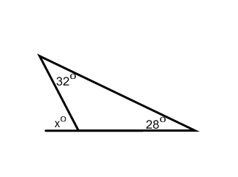**9.** Given the following diagram, find the value of *x*. ***(3 pts)***

Explain how you arrived at your answer.

__________________________________________________________________

__________________________________________________________________

__________________________________________________________________

__________________________________________________________________

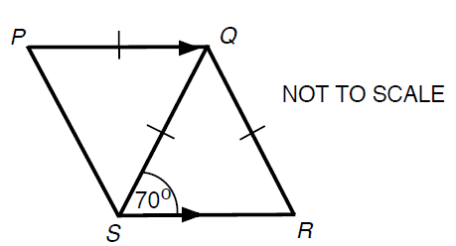**10.** Are triangles *PQS* and *QRS* similar? Show work ***and*** explain. ***(3 pts)***

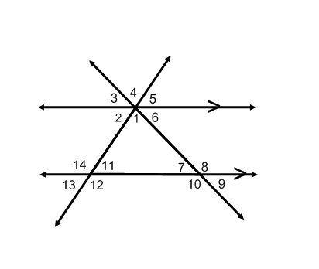**11.** If the  and .

Complete the table below for each angle and explain. ***(5 pts)***

|  |  |  |
| --- | --- | --- |
| **Angle** | **Measure** | **Reason** |
|  |  |  |
|  |  |  |
|  |  |  |
|  |  |  |
|  |  |  |