**Name: _________________________________ Date: ________________________**

**M8-U3: HW #2 – Reflections Class: ________________________**

**1.** Find the reflection of the triangle *HOT* over the *x-axis*.

Write the coordinates of *H’O’T’*. Is the image similar or congruent? How do you know?



**2.** Find the reflection of the quadrilateral *WXYZ* across the dotted line.



What is the equation of the dotted line?

Label the image *W’ X’ Y’ Z’*.

**3.** The table below shows the coordinates of triangle *PQR*.

|  |  |  |  |
| --- | --- | --- | --- |
| **Triangle**  ***PQR*** | | **Triangle**  ***P’Q’R’*** | |
| ***P*** | (-3, 2) | ***P’*** |  |
| ***Q*** | (-3, 6) | ***Q’*** |  |
| ***R*** | (-7, 7) | ***R’*** |  |

***Part A***

Fill in the table above for the coordinates of *P’, Q’,* and *R’* after a

reflection over the *y*-axis*.*

***Part B***

On the grid below, draw triangle PQR and triangle *P’Q’R’*.



***Part C***

On the lines below, explain how you determined the location of *R’*.

________________________________________________________________________

________________________________________________________________________

**4.** Triangle *XYZ* has vertices *X* (2, 1), *Y* (6,1), and *Z* (4, 4).

On the graph, draw the image of triangle *XYZ* after a translation two to the left. Label the image *X’Y’Z’*

Now create triangle *X”Y”Z”* by reflecting triangle *X’Y’Z’* over the *x-*axis. What will be the coordinates of triangle *X”Y”Z”* ? Is the new image similar or congruent?

**5.** Describe a reflection that would move shape 1 to match shape 2.

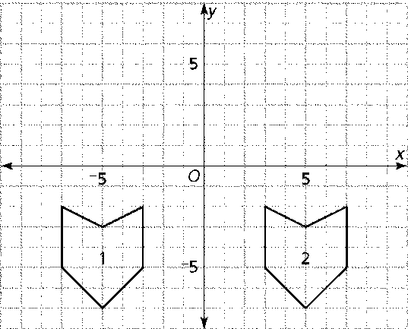

___________________________________

___________________________________

___________________________________

**6.** Refer to the grid below:

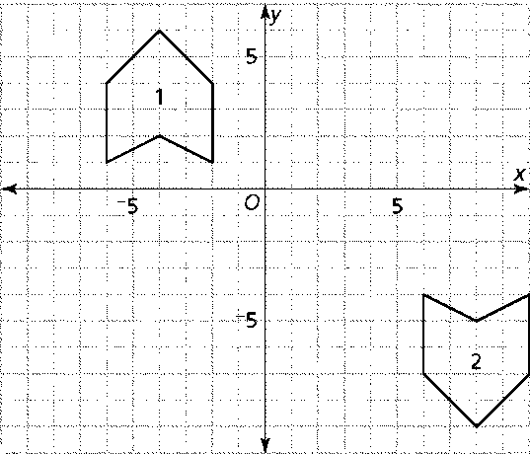

1. Describe how you could move shape 1 to exactly match shape 2 by using one translation and one reflection.
2. Are there other sequences of transformations that would move shape 1 to exactly match shape 2? If so, describe the steps you would perform.

**Spiral:**

**7.** Solve and check:  **8.** Solve: 