**Name: ______________________ Class: __________________**

**M8-U3: HW# 3 – Dilations Date: __________________**

***Multiple Choice:***

**1.** Which of the following describes the image of a figure after a dilation that has a scale factor between zero and one?

1. It has a different shape from the original figure and is smaller than the original figure.
2. It has the same shape as the original and is larger than the original figure.
3. It has the same shape as the original and is smaller than the original figure.
4. It has the same shape and same size as the original figure.

**2.** Which of the following describes the image of a square after a dilation that has a scale factor of 6?

1. Its sides are 6 units longer than those of the original square.
2. Its sides are  as long as those of the original square.
3. Its sides are 6 times as long as those of the original square.
4. Its sides are 6 units shorter than those of the original square.

**3.** Which of the following describes the image of a triangle after a dilation that has a scale factor of ?

1. Each angle has  of the measure of its corresponding angle in the original triangle.
2. Each angle has  of the measure of its corresponding angle in the original triangle.
3. Each angle has the same measure as its corresponding angle in the original triangle.
4. Each angle is  larger than the measure of its corresponding angle in the original triangle.

**4.** What are the coordinates of  after a dilation with a scale factor of ?

**a)**  **b)** 

**c)**  **d)** 

**5.**  is the image of  after a dilation with a scale factor of 2. What are the coordinates of the vertices of ?



**a)**  **b)** 

**c)**  **d)** 

***Short Answer:***

**6.** Triangle *PQR* has coordinates . Write the coordinates of the vertices of the image of a triangle after a dilation of 1.5.

**7.** How does the size of an image compare to the original figure when the original figure undergoes a dilation with a scale factor of one?

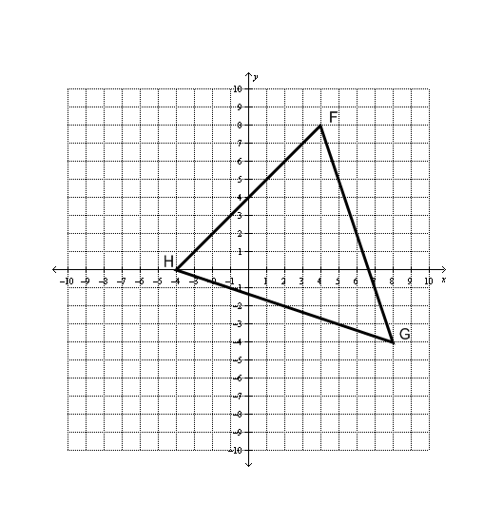

**8.** On the grid below, draw the image of  after a dilation with a scale factor of .

What will be the coordinates of point *F”* after a translation of polygon *F’G’H’* two units to the left and four units up?

***Answer ______________***

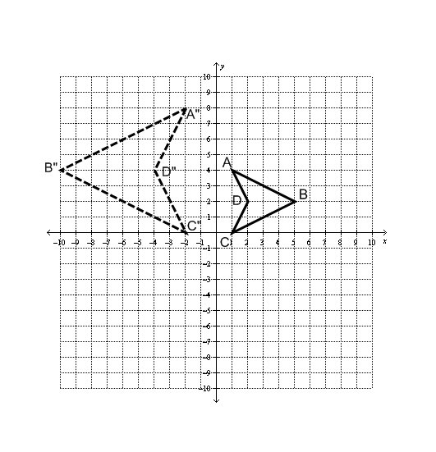**9.** Describe a sequence of transformations to get from polygon *ABCD* to polygon *A”B”C”D”*.

___________________________________________________________________

___________________________________________________________________

___________________________________________________________________

**Spiral:**

**10.** Solve: 