**Name: ______________________ Class: ________________________**

**M8-U3: HW# 4 – Rotations Date: ________________________**

**1.** **a)** Graph Triangle RST with vertices R, S and T

**b)** Using the rule for a rotation of 90° counterclockwise, graph Triangle  on the graph below and write the new coordinates.





**2.** Quadrilateral *ABCD* is plotted on the grid below.



**Part A**

On the graph, draw the image of quadrilateral *ABCD* after a counterclockwise rotation of 180o about the origin. Label the image .

**Part B**

On the lines below, explain how the coordinates of *A* changed to the coordinates of .

__________________________________________________________________

__________________________________________________________________

__________________________________________________________________

**3.** Point *A* (3, 6) is rotated 270° counterclockwise about the origin, what is the coordinate of? *Circle the best answer.*

**(a)**  **(c)** 

**(b)**  **(d)** 

**4.** Draw the final image created by rotating polygon *ABCD* 90° counterclockwise about the origin and then reflecting the image in the *x*-axis.

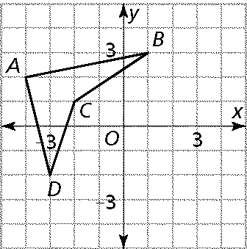

Is the resulting image similar or congruent? How do we know?

**5.** Determine the transformation that produced the following images:

a) b)

**6.** Quadrilateral *PQRS* is plotted on the grid below.

On the graph, draw the image of polygon *PQRS* after a 90o clockwise rotation. Label the image *P’Q’R’S’*.



What will be the coordinates of point *Q”* after a dilation of polygon *P’Q’R’S’* using a scale factor of two?

***Answer ______________***

**7.** Describe how you could move shape 1 to exactly match shape 1’ by using series of transformations?

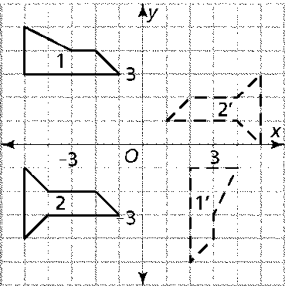

**Spiral:**

**8.** The image of  after a translation of  is __________.

**9.** A dilation of  will make the coordinates of the image _______ times larger than the original.

**10.** The only transformation that changes the size of the original figure is a ________.