**Name: ______________________ Class: __________________**

**M8-U3: Notes# 4 – Rotations Date: __________________**

**Rotation** - turning a figure about a fixed point

How can we turn objects?

1.

2.

We need to know the two “D’s” of rotations:

1.

2.

After a rotation has been performed, is the image going to be similar or congruent? Explain.

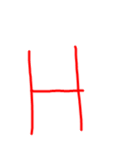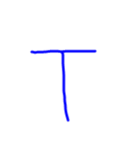

**Example:**

**1.** Triangle *ABC* is labeled on your graph below.

1. Rotate Triangle *ABC*, 90o counterclockwise. Label the triangle *A****′*** *B****′*** *C***′**.
2. Rotate Triangle *ABC*, 180o counterclockwise. Label the triangle *A″ B″ C″*.
3. 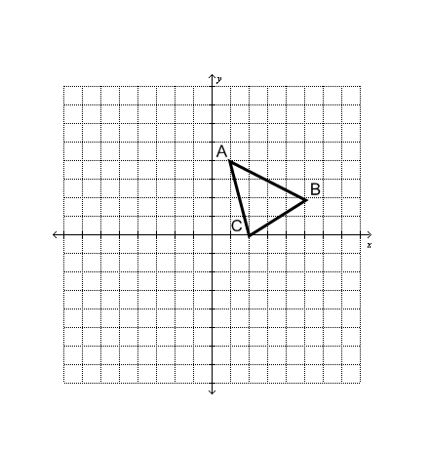Rotate Triangle *ABC*, 270o counterclockwise. Label the triangle *A****′′′*** *B****′′′*** *C****′′′***.

**2.** Organize your results from Part A in the table.

|  |  |  |  |  |
| --- | --- | --- | --- | --- |
| **Starting Point** | **90°**  **Rotation CC** | **180°**  **Rotation CC** | **270°**  **Rotation CC** | **360°**  **Rotation CC** |
| ***A* (1, 4)** |  |  |  |  |
| ***B* (5, 2)** |  |  |  |  |
| ***C* (2, 0)** |  |  |  |  |

**3.** Complete each rule for finding the image of any point (*x, y*) under the given rotation.

a) 90**°** rotation about the origin: (*x, y*) → ( , )

b) 180**°** rotation about the origin: (*x, y*) → ( , )

c) 270**°** rotation about the origin: (*x, y*) → ( , )

d) 360**°**  rotation about the origin: (*x, y*) → ( , )

**4.** What are the coordinates of (3, - 2) under a 90**°** counterclockwise rotation about the origin?

**5.** What are the coordinates of (- 5, 4) under a 180**°** counterclockwise rotation about the origin?

**6.** What are the coordinates of ( 3, 2) under a 90**°** **clockwise** rotation about the origin?

**7.**

**a.** Draw the final image created by rotating triangle *RST* 90° counterclockwise about the origin and then reflecting the image in the *x*-axis.



**b.** Draw the final image created by reflecting triangle *RST* in the *x*-axis and then rotating the image 90° counterclockwise about the origin.



**c.** Are the final images in parts (a) and (b) the same? Why or why not?

Rotation Summary

