**Name: ______________________ Class: __________________**

**M8-U5: Notes & HW #5 – Practice Date: __________________**

**1.** Find the coordinates of the image *ABCD* with vertices *A*(0, 0), *B*(0, 3), *C*(3, 3), and *D*(3, 0) after a dilation with a scale factor of .

**2.** **a)** Find the coordinates and graph the image of quadrilateral *WXYZ* after a dilation about the origin with a scale factor of . **b)** If the image was rotated 90o clockwise, what would be the coordinates of *X”*?

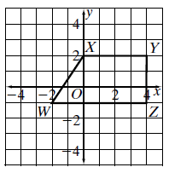

**3.**  is a dilation of . Find the scale factor.

Is it an enlargement or a reduction?



**4.** Figure *EFGH* shows the outline of a yard. Figure *E’F’G’H’* is a doghouse. Figure *E’F’G’H’* is a dilation of figure *EFGH*. Find the scale factor. Is it an enlargement or a reduction?

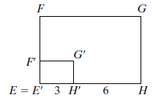

**5.** A triangle has coordinates *A*(-2, -2), *B*(4, -2), and *C*(1, 1). Graph its image *A’B’C’* after a dilation with scale factor .Give the coordinates of *A’B’C’*, and the ratio of the areas of the figures *A’B’C’* and *ABC*.

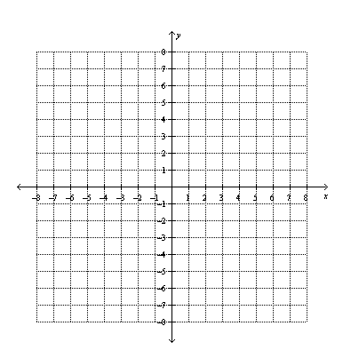

**6.** A graphic artist tried to translate a copy of the original school bus drawing below, but he accidentally left one of the windows behind.

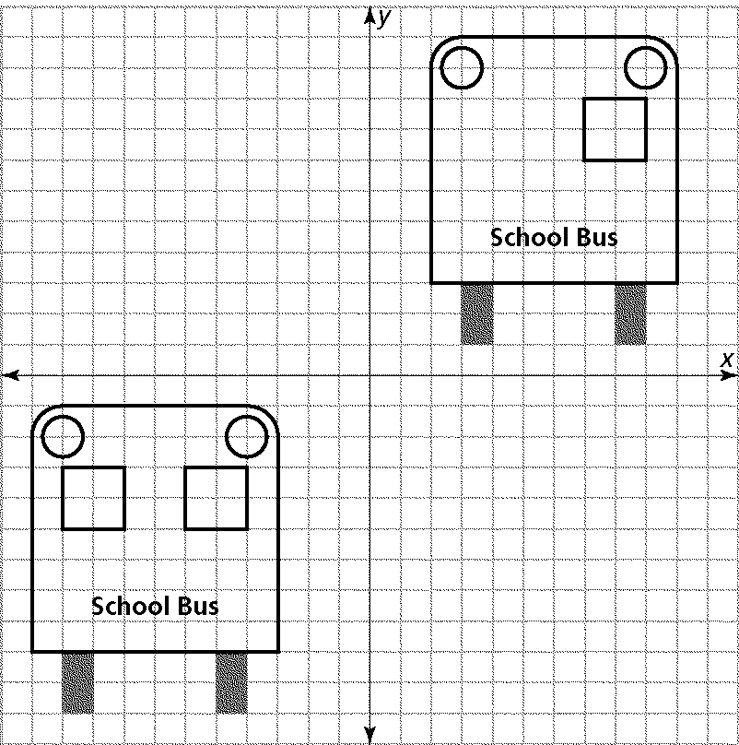

**a)** Make a table showing the coordinates of the vertices of the left window of the original bus and the coordinates of the vertices that this window should have in the image.

**b)** Describe the translation so someone else could start with the drawing of the original bus in the bottom left-hand corner and draw the correct image shown in the upper right-hand corner.

**7.** Draw and label the image of the figure after a reflection over the *x*-axis.

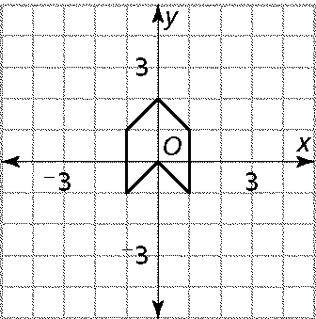

**8.** Draw and label the image of the figure after a reflection over the line .



**9.** Based on the given drawing, determine the specific transformation.



**10.** Based on the given drawing, determine the specific transformation.



**11.** Rectangle *ABCD* has vertices *A*(–4, –3), *B*(–4, –2), *C*(–1, –2), and *D*(–1, –3). Graph *ABCD* and its translation 5 units to the right and 3 units up. Then rotate the image 90o counterclockwise, label the resulting figure appropriately.



**12.** Is rotating the point *L*(4, 4) about the origin the same as reflecting the point over the *x*-axis? Explain.



__________________________________________________________________

__________________________________________________________________

__________________________________________________________________

**13.** Reflect triangle *ABC* over the line shown.

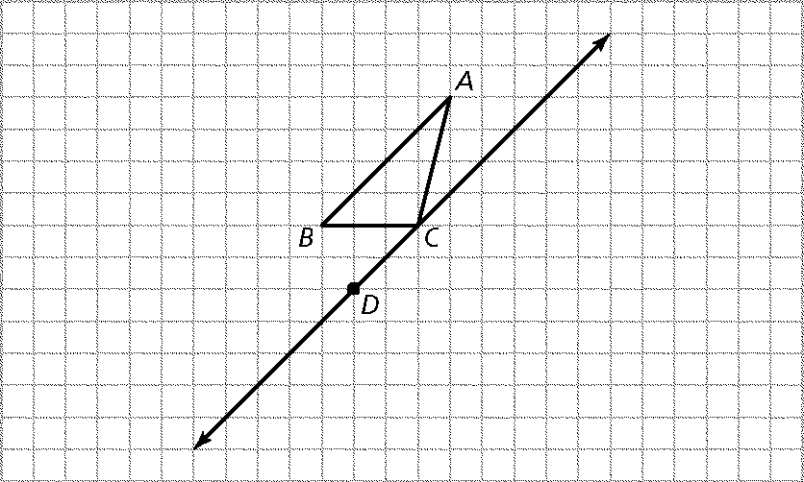

**14.** What single transformation is equivalent to a reflection in the *y*-axis, followed by a reflection in the *x*-axis, followed by a reflection in the *y*-axis?

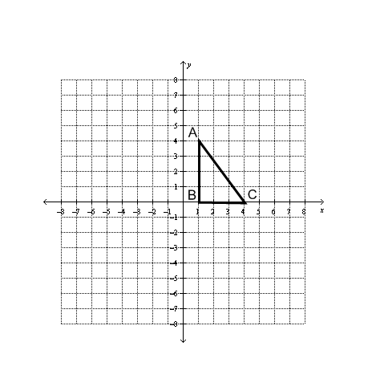

**15.** What single transformation is equivalent to a reflection in the *x*-axis, followed by a reflection in the *y*-axis?

***Multiple Choice:***

**16.** The width of a picture is 20 cm. Using a color copier, you reduce the width of the picture to 5 cm. What is the scale factor of the dilation?

**a)** 5 **b)**  **c)** 4 **d)** 

**17.** Which translation below is NOT described by the rule ?

**a)**  **b)** 

**c)**  **d)** 

**18.** Use arrow notation to write a rule that describes the translation shown on the graph.



**a)**  **b)** 

**c)**  **d)** 

**19.** At the half-time show, a marching band marched in formation. The lead drummer started at a point with coordinates (3, 4) and moved 3 steps down and 4 steps left.

1. Write a rule to describe the translation
2. What were the coordinates of the drummer’s final position?

**a)**  **b)** 

**c)**  **d)** 

**20.** Suppose a constellation of stars is plotted on a coordinate plane. The coordinates of one star are (–2,1). The star is translated up 5 units. What are its new coordinates?

**a)** (-2, 6) **b)**  **c)** (3, 1) **d)** 

**21.** Rectangle *ABCD* has vertices *A*(–3, 1), *B*(–3, 2), *C*(–2, 1), and *D*(–2, 2). Graph *ABCD* and its translation 2 units to the right and 4 units down.

|  |  |  |  |
| --- | --- | --- | --- |
| **a)** |  | **c)** |  |
| **b)** |  | **d)** |  |