**Name: _____________________ Class: _________________**

**M8-U3: Lesson #6 – Unit 3 Transformations Task**

**1.** Finish Aaron’s first design by reflecting the gray shape over the *y*-axis.

Now reflect the original and its image over the line .



**2**. A triangle *ABC* with vertices at *A*(2, -2), *B*(2, 3), *C*(-4, -2) is reflected over the *x*-axis, rotated 90o clockwise about the origin, and then translated 3 units down and 2 units left.

**Part A:** *Describe* the operations you must perform on the coordinates of the vertices for each transformation listed above. *List* the coordinates of the new vertices after each transformation.

**Reflection over the *x*-axis**

**________________________________________________________________________**

**Rotation 90o clockwise about the origin**

**________________________________________________________________________**

**Translation**

**________________________________________________________________________**

**Part B:** Graph both the original triangle and the *final* image after all transformations have been performed, label all coordinates.



**Part C:** Is the new triangle congruent to the original triangle? Explain.

**3.** Triangle *ABC* and triangle *A”B”C”* are plotted on the coordinate plane below.

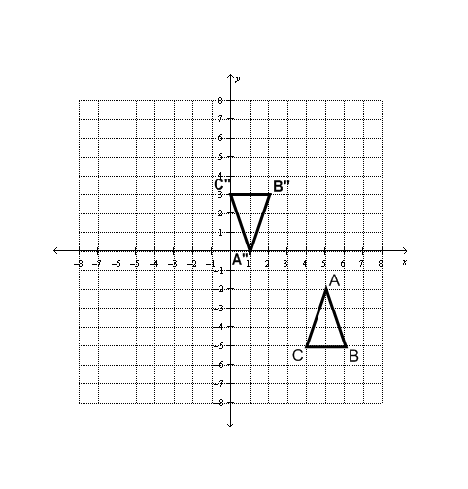

Describe how you could move the ∆*ABC* to exactly match ∆ *A”B”C”* using a series of two transformations.

________________________________________________________________________

________________________________________________________________________

**4.** Triangle *DEF* is rotated 900 counterclockwise and then dilated using a scale factor of 3.

Which parts are congruent and which are similar? Explain.

How do the perimeters compare? Explain.

How do the areas compare? Explain.

**5.** Square *ABCD* is reflected over the *y*-axis and then dilated using a scale factor of ½.

Which parts are congruent and which are similar? Explain.

How do the perimeters compare? Explain.

How do the areas compare? Explain.

**6.** Parallelogram *ABCD* and parallelogram *A”B”C”D”* are plotted on the coordinate plane below.

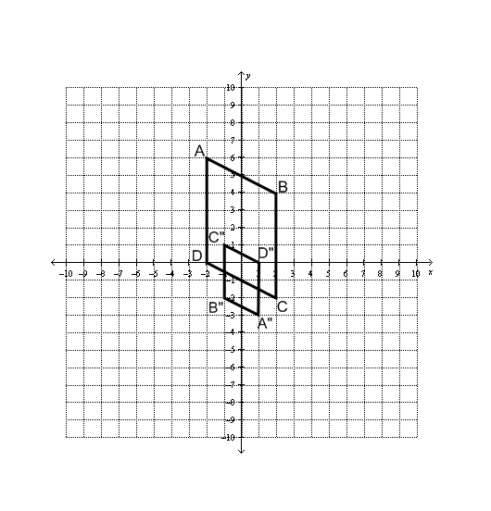

Describe a sequence of transformations to determine how parallelogram *ABCD* matches to parallelogram *A”B”C”D”*.

________________________________________________________________________

________________________________________________________________________

________________________________________________________________________