**Name: ______________________ Class: __________________**

**M8-U5: HW #2 – Graphing Systems (Day2) Date: __________________**

**Graph the two linear equations and find the solution.**

**1.**  **2.** 



**3.**  **4.** 



**5. **

**Find the solution to the given systems.**

**6. 7.**

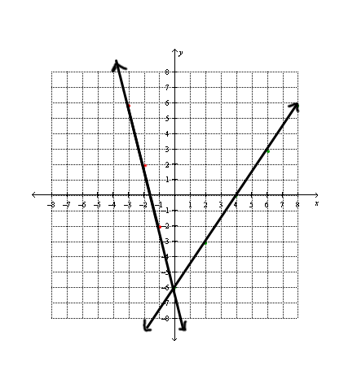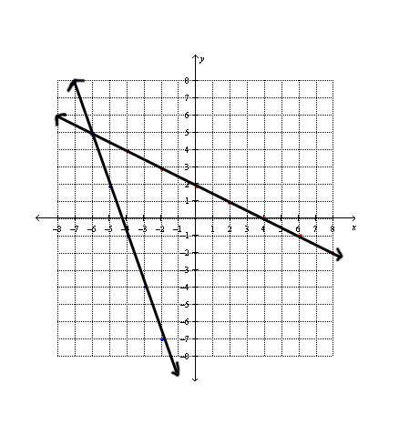

**Spiral – Show all work:**

***Solve the following equations:***

**8.** **9.** 