**Name: ______________________ Class: __________________**

**M8-U5: Notes #2 – Graphing Systems (Day2) Date: __________________**

**Warm-Up:**

Graph the two linear equations and **find the solution**.





**Graphing a system of equations in different forms:**



**1. Find the solution to the system.**



**2. Find the solution to the system.**





**Try It!**

**Find the solution the following system.**





**Try It!**

**Find the solution the following system.**





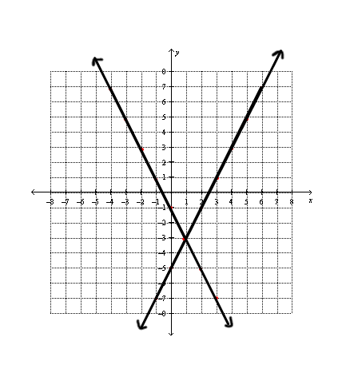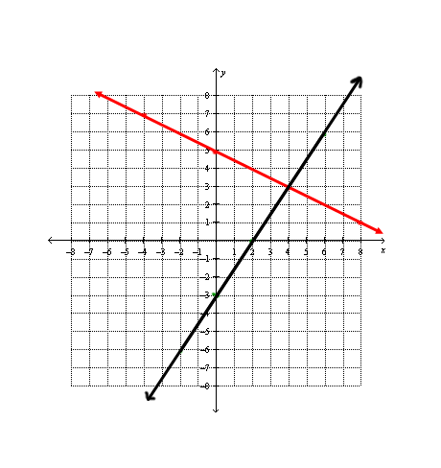

**Find the solution to the given systems.**

**3. 4.**

**5. Find the solution the following system.**



