**Name: ______________________ Class: __________________**

**M8-U5: Notes & HW #8 – Practice Solving Systems**

**Date: __________________**

**Solve the following systems algebraically, find the solution.**

**1.**  **2.** 

**3.**  **4. **

**Find the solution to the** **following systems graphically.**

**5.  6.** 



**7.**  **8.** 



What is the solution of the system of linear equations graphed below?

**9.** **10.**

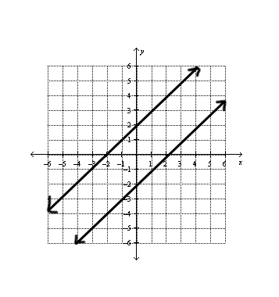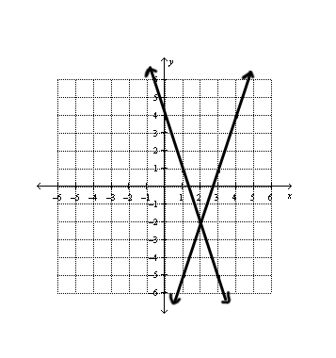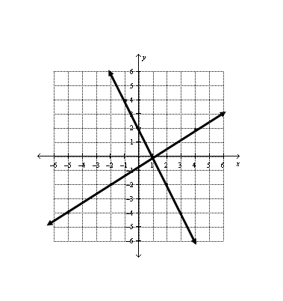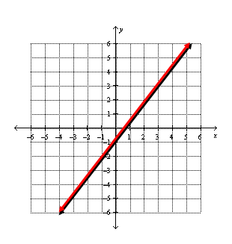

**11.** **12.**

**13.** Sam is planning a ski trip and wants to figure out which mountain offers the best deal. Sam needs to rent skis and buy a lift ticket. He researched his options, and he found the following two packages which include ski rental and lift ticket:

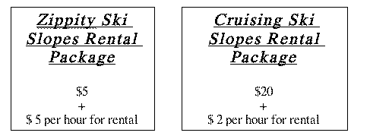

Under what circumstances are the costs for the ski packages the same, and what will that cost be?

**14.** Marcello is an artist who makes oil paintings and charcoal sketches. He sells each oil painting for $500 and each charcoal sketch for $300. If Marcello wants to create 56 works in total, how many pieces of artwork must he sell in order to make exactly $20,000?

**Spiral:**

**Solve the equation and check your solution.**

**1.**  **2.** 

**Find the value of *y* when *x* = -2.**

**3.**  **4.** 

**Calculate the *y*-value for the given *x*-value.**

**5.**  when *x* = 24 **6.**  when *x* = 

**7.**  when *x* = -18 **8.**  when *x* = -6

**Write an equation for the line satisfying the given conditions.**

**9.** passes through (4, 0) and (0, 3)

**10.** slope = , passing through the point (3, 4)

**11.** passes through the points (5, 4) and (1, 7)