**Name: ______________________ Class: __________________**

**M8-U6: HW #8 – Applications of Scientific Notation Date: __________________**

Convert the following measurements:

**1.**  m = __________ km **2.**  m = __________ mm

**3.**  bytes = __________ kilobytes **4.**  g = __________ mg

**5.** 0.05 g = __________ centigrams **6.** 6,400,000 ton = __________ kiloton

**7.** The space shuttle can travel about  centimeters per second. What is the speed of the space shuttle in kilometers per second? Explain why it is more appropriate to report this speed in kilometers per second.

**8.** The inside diameter of a certain size of ring is  meter. What is the diameter of the ring in millimeters? Explain why it is more appropriate to report this measurement in millimeters.

**9.** A blue whale has a mass of about 190,000,000 grams. The mass of a whale shark is approximately  kilograms. What is the sum of the masses of the blue whale and whale shark? Should the mass be expressed in grams or kilograms? Explain your reasoning.

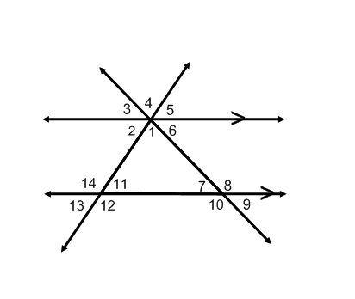

**Spiral:**

**10.** If the  and  find the stated angles.

___________________

___________________

___________________

**11.** Write an equation for the line that passes through the points (1, 1) and (3, 9).