**Name: ______________________ Class:__________________**

**M8-U8: HW #1 - Volume of 3-D Figures - Cylinders Date:___________________**

Find the **volume** of each prism. Show all work.

**1. 2.**

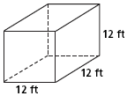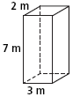

Find the **volume** of each cylinder.

Show all work.

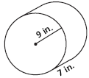

**3. 4.**

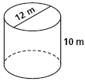

**Volume = ____________________ Volume = _____________________**

**Find the volume to the nearest tenth.**

**Volume ≈ ____________________ Volume ≈ _____________________**

**5.** A soda can has a diameter of 3in and a height of 5in.

1. Find the volume in terms (leave in terms of π).
2. Double the radius, find the new volume (leave in terms of π).
3. How do the two volumes compare?

**6.** A drink coaster in the shape of a cylinder has a volume of approximately

95.43 cm3 and a radius of 4.5cm. Approximately how many coasters would you need to reach a height of 7.5cm?

**7.** The volume of a cylinder is about 1632 in3. The height of the cylinder is 24in. What is the area of the base?

**8.** Tanya uses a cube shaped bead with side lengths measuring 12mm. Each bead has a circular hole in the middle. The diameter of the circular hole is 2mm. Find the volume of the bead. *Hint: draw a picture.*

**Spiral:**

**1.** What is the slope of the line whose equation is ?

a) 3 b) 12 c) -3 d) -12

**2.** What is the y-intercept of the line whose equation is ?

a) 5 b) 1 c) -5 d) 0

**3.** A line has a slope of 5 and a *y*-intercept of -1. What is the equation of the line?

a)  b)  c)  d) 

**4.** What is the equation of the line on the following graph?

