**Name: ______________________ Class: __________________**

**M8-U8: Notes #1 - Volume of 3-D Figures - Cylinders Date: __________________**

**Volume** – the number of cubic units needed to fill a solid.

To find the volume of a prism or cylinder, multiply the base area (*B*) by the height *h*.

**A. Rectangular prisms**

Formula:  (what is the base in a rectangular prism?)

*V* = (length)(width)(height)

**Example 1: Example 2:**

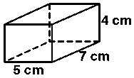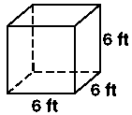

**Volume = ______________ Volume = _______________**

**B. Cylinders – have two bases that are parallel, congruent circles.**

Formula:  (what is the base in a cylinder?)

*V* = 

(Since the area of the base is a circle, the area of a circle is . We have to multiply by its height.)

**Find the volume.**

**Example 3: Example 4:** (Hint: What’s the radius?)

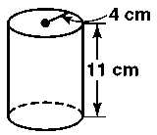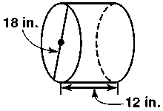

**Volume = ____________________ Volume = _____________________**

**Find the volume to the nearest tenth.**

**Volume ≈ ____________________ Volume ≈ _____________________**

**C. Comparing/Analyzing volumes.**

**Example 5:**

1. Given the following figure, find the volume (leave in terms of π).



1. Double the height, find the new volume (leave in terms of π).
2. How do the two volumes compare?
3. Double the radius of the original cylinder, find the volume (leave in terms of π). How does this volume compare to the one you found in part a? Why?

**D. Determining missing lengths.**

**Example 6:**

The volume of a cylinder is 405 with a diameter of 18. Find the height of the cylinder.

**Example 7:**

A can of soup contains about 553 cubic centimeters of soup. The height of the can is 11 cm. What is the approximate diameter of the can to the nearest centimeter?

**Example 8:**

The Robert’s family uses a container shaped like a cylinder to recycle aluminum cans. It has a diameter of 1.5 feet and a volume of 2.25π ft3. If the container is filled half way to the top, what is the height that the cans reach?

**Additional Practice:**

**Find the volume of each solid. Show all work.**

**1. 2.**

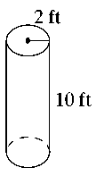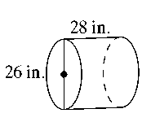

**Volume = ____________________ Volume = _____________________**

**Find the volume to the nearest tenth.**

**Volume ≈ ____________________ Volume ≈ _____________________**

**3.** A scented candle is in the shape of a cylinder, with a radius of 4cm and a height of 12cm.

1. Find the volume (leave in terms of π).
2. Double the radius, find the new volume (leave in terms of π).
3. How do the two volumes compare?

**4.** A cylindrical cake takes up 32π cubic inches. The diameter of the cake is 8 inches, what is the height of the cake?

**5.** The human eye contains “rods”, primarily responsible for night vision, which have an approximate diameter and length of meters and  meters respectively. What is the approximate volume of the solid?

**6.** Nate uses a cube shaped bead with side lengths measuring 6mm. Each bead has a circular hole in the middle. The diameter of the circular hole is 3mm. Find the volume of the bead.

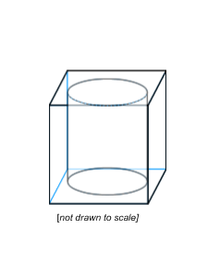

**Volume = ____________________**

**Find the volume to the nearest tenth.**

**Volume ≈ ____________________**