**Name: ______________________ Class:__________________**

**M8-U8: HW #2 - Volume of 3-D Figures - Cones Date:___________________**

Find the **volume** of each solid.

Show all work.

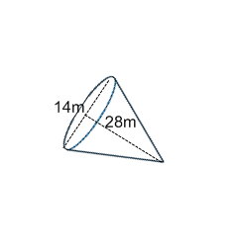

**1. Find the volume.**

**Volume = ____________________**

**Find the volume to the nearest tenth.**

**Volume ≈ ____________________**

**2.** A snow cone has a diameter of 3in and a height of 5in.

1. Find the volume in terms of pi.
2. Triple the height; find the new volume (leave in terms of π).
3. How do the two volumes compare?

**3.** A funnel can hold 159π cm3 of fluid.Its height (without the stem) is 12 cm. What is the diameter of the cone part of the funnel to the nearest tenth?

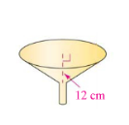

**4.** April is filling six identical cones for her piñata. Each cone has a radius of 1.5 inches and height of 9 inches. What is the total volume of the cones?

**5.** The volume of cone with a 30mm radius is 9420 cubic millimeters. What is the height of the cone to the nearest millimeter?

**6. Find the volume in terms of pi.**

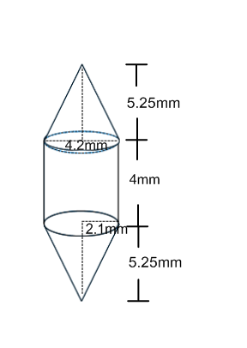

**Volume = _____________________**

**Find the volume to the nearest tenth.**

**Volume ≈ ____________________**

**Spiral:**

Evaluate the following:

**1.**  **2.** 

Solve and check the following equations:

**3.**  **4.** 