**Name: ______________________ Class: __________________**

**M8-U8: Notes #2 - Volume of 3-D Figures - Cones Date: __________________**

**A. Cone – has one base that is a circle and then meets at a common vertex.**

Formula:  (what is the base in a cone?)

**For Examples 1 and 2,** **find the volume of each cone.**

**Example 1a: Example 1b:** (Hint: What’s the radius?)



**Volume = ____________________ Volume = _____________________**

**Find the volume to the nearest tenth.**

**Volume ≈ ____________________ Volume ≈ _____________________**

**B. Comparing/Analyzing volumes.**

**Example 2:**

1. Given the following figure, find the volume (leave in terms of π).



1. Draw a cone with the same dimensions as the figure above, what is the cones volume (leave in terms of π)?
2. How do the two volumes compare?

**Example 3:**

What would have a greater effect on the volume of a cone: doubling its radius or doubling its height? *(Use the information from 2b to get started)*

1. Double radius: **b)** Double height:

**C. Determining missing lengths.**

**Example 4:**

The volume of a cone is 405 in3 with a diameter of 18in. Find the height of the cone.

**Example 5:**

An ice cream shop designs a new ice cream cone. He wants the volume to be about 240cm3. The cone is 14cm tall. What is its radius to the nearest whole number?

**D. Composite Volume**

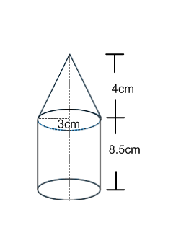

Find the volume of each solid in terms of pi.

**Example 6: Example 7:**

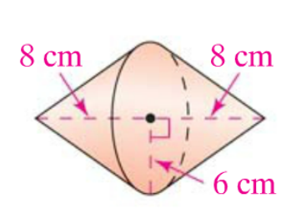

**Additional Practice:**

**Show all work.**

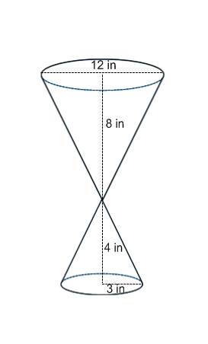

**1. Find the volume.**

**2.** Bob is building a storage shed in a conical shape. The base of the shed is 4 meters in diameter and the height of the shed is 3.6 meters. What is the volume?

**3.** A machine uses a funnel in the shape of a cone to fill soda cans on an assembly line. The funnel has a height 10cm and a diameter of 8cm. How many times would the machine need to fill the cone to then fill a can of the same dimensions? *(Show work to prove the answer.)*

**4.** Find the diameter, to the nearest unit, of a cone with an approximate volume of

22 ft3 and a height of 21ft.

**5.** The human eye contains “cones”, primarily responsible for color vision, which have an approximate diameter and length of meters and  meters respectively. What is the approximate volume of the solid?