**Name: ______________________ Class: _________________**

**M8-U8: HW #3 - Volume of 3-D Figures - Spheres Date: __________________**

**Show all work.**

**1.** Find the volume of the sphere with a diameter of 15 inches. *Leave in terms of pi.*

**2.** Find the volume of a hemisphere with a radius of 6.8 feet. *Round to the nearest tenth*.

**3.** Three tennis balls are packaged in a box. The box is 12.1cm long, 3.5cm wide and 3.5 cm tall. Each ball is 3.3cm in diameter. What is the volume of the empty space in the box?

**4.** A cylindrical can contains an unknown number of golf balls. The can has a height of 10in and a volume of 15.625π in3. How many golf balls fill the can if they are uniform in size to the container?

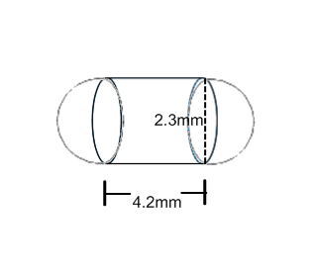

**5.** Here are the dimensions of a pill. Find the volume to the nearest tenth.

**6.** A snow globe in the shape of a hemisphere has a volume of  in3. Find the diameter.

**Spiral:**

**1.** Graph a line that goes through the following 2 points**, ** and write the equation.



**Solve the following systems.**

What is the **solution** to the following system of linear equations?

If there is *no solution* or *infinitely many*, explain why.



**2.** 