**Name: ______________________ Class: __________________**

**M8-U8: Notes #3 - Volume of 3-D Figures - Spheres Date: __________________**

**A. Spheres – the set of all points in space that are the same distances from a center point.**

Formula: 

**For Examples 1 and 2,** **find the volume of each sphere.**

**Example 1: Example 2:** (Hint: What’s the radius?)

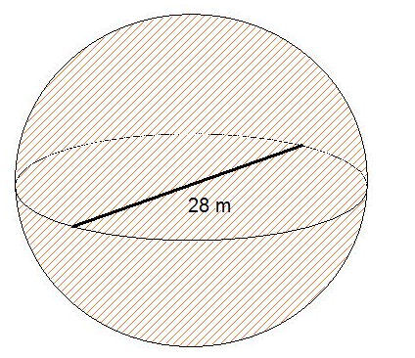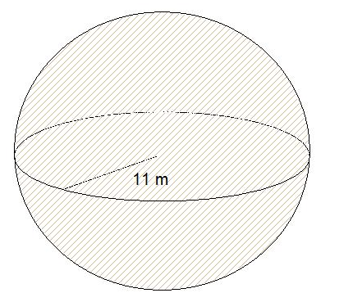

**Volume = ____________________ Volume = _____________________**

**Find the volume to the nearest tenth.**

**Volume ≈ ____________________ Volume ≈ _____________________**

**B. Comparing/Analyzing volumes.**

**Example 3:**

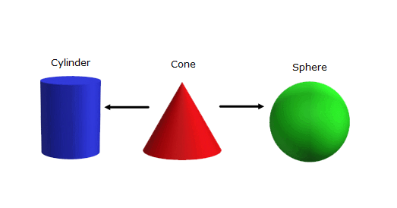

1. Given the following figures, let’s analyze their formulas. Restate their formulas under the pictures.
2. How many cones fit inside a cylinder?
3. How many cones fit inside a sphere?

**Example 4:**

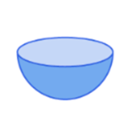

Hemisphere – a circle separates a sphere into two congruent halves.



Find the volume of the hemisphere with a diameter of 15 km. Round to the nearest tenth.

**C. Determining missing lengths.**

**Example 5:**

The volume of a golf ball is 41.63 cm3. What is the radius of the golf ball to the nearest tenth?

**Example 6:**

The volume of a baseball is about 13.39 cubic inches. What is the diameter of the baseball to the nearest tenth?

**D. Composite Volume**

**Example 7:**

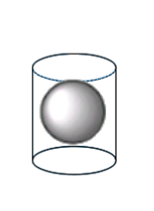

Find the remaining volume of the cylinder if the height of the cylinder is 6m, the radius of the cylinder is 3m, and the ball has a radius of 3m.

[*not drawn to scale*]

**Additional Practice:**

**Find the volume of each solid. Show all work.**

**1.** Approximately how much air would be needed to fill a dozen soccer balls with a radius of 14cm? *Round to the nearest hundredth*.

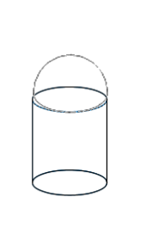

**2.** Find the volume of the following figure if the diameter is 4.5 in and the height of the cylinder is 2.5 in. *Round to the nearest tenth*.

**3.** The diameter of the earth is approximately 7,926 miles. The diameter of the moon is approximately 2,159 miles. Approximately how many moons would fit inside the earth?

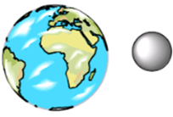

**4.** Find the radius of a sphere with a volume of 1,767.1 m3. *Round to the nearest tenth*.

**5.** Find the radius of a hemisphere with a volume of 2,712.3 in3. *Round to the nearest tenth*.