**Name: ______________________ Class: __________________**

**M8-U8: Notes & HW #4 – Practice Date: __________________**

**Directions:** Find the volume for the following figures/situations.



**1.** **2.**

**Volume = ____________________ Volume = ____________________**

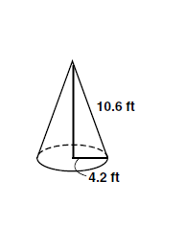

**3.**

**Find the volume to the nearest tenth.**

**Volume ≈ ____________________**

**4.** Find the volume of a cylindrical cake that is 5 in. tall with a radius of 7.5 in.

**5.** A funnel in the shape of a cone is used to hold water in the town of Hicksville, KY. The height of the cone tower is 12m with a diameter of 6m, what is the volume?

**6.** A standard men’s basketball has a circumference of about 29.5 inches. What is the volume of the basketball to the nearest hundredth? *(hint: find the diameter first.)*

**7.** A cylindrical container is used to hold dog food. Its volume is approximately 50.27 ft3 and has a radius of 2 ft. What is the height of the container to the nearest foot?

**8.** The volume of a cone is cm3 with a height of 4cm, what is the length of the diameter?

**9.** A globe in a brass stand has an approximate volume of 33,510.32 in3, what is its radius length?

**10.** Find the volume.



**11.** Find the volume.



**12.** Find the volume, to the nearest tenth, of a 4 ft by 2 ft by 3 ft rectangular prism with a cylindrical hole, radius 6 in., through the center.



**13.** Marge has a cylindrical tin of popcorn that is 18 in. tall and has a radius of

4 in. She wants to use the tin for something else and needs to empty the popcorn into a box. The box is 8 in. long, 8 in. wide and 14 in. tall. Will the popcorn fit in the box? Explain.

**14.** Take a hemisphere and a cylinder with an equal base and height.Fill the hemisphere with water and then pour the water into the cylinder, how far up the cylinder will the water reach? *(Hint: try some numbers out.)*

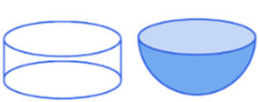

**Multiple Choice:**

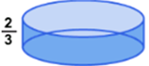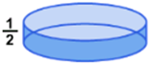

a) b) c)

**15.** Spaceship Earth at Epcot Center in Florida is a 180-foot geosphere. Find the volume by assuming it is a sphere with a diameter of 180 feet.

**16.** If you have a cylinder and double the radius and height how does it affect the volume?

**17.** A cylinder has a radius and height of feet and  feet respectively. What is the approximate volume of the solid?

**18.** A cone has a diameter and length of inches and  inches respectively. What is the approximate volume of the solid?